**CIDOC-CRM URIs NAMESPACE MECHANISM (using 303-redirect mechanism)**

Christos Georgis

Centre for Cultural Informatics / FORTH-ICS  
17/01/2013

**Description of mechanism**

Below we describe CIDOC CRM generic (version independent) namespace mechanism for the interpretation of the CIDOC CRM as RDF schema: http://www.cidoc-crm.org/cidoc-crm.It provides details on current implementation (v5.0.4 or later), changes from previous namespace implementations and backward compatibility.

Each entity represented in a particular data set leads to the minting of at least three URIs[1]:

1. a URI for the real-world object itself
2. a URI for a related information resource that describes the real-world object and has an HTML representation
3. a URI for a related information resource that describes the real-world object and has an RDF/XML representation

In order to publish the CIDOC-CRM vocabulary and to provide the above three URIs, we followed the W3C Working Group Note “Best Practice Recipes for Publishing RDF Vocabularies” [2]*.* We have extended the configuration for a 'slash namespace‘, using a single HTML document.

We configured our server to provide either human-readable (HTML) or machine-processable (RDF) content from the vocabulary URI, depending on what is requested, and to redirect the client from class and property URIs to the appropriate content locations containing the current version[3] of HTML or RDF file, again depending on what is requested. The HTML documentation is served as a single file.

So we were able to use URI http://www.cidoc-crm.org/cidoc-crm to:

* Dereference the vocabulary URI, requesting HTML content
* Dereference the vocabulary URI, requesting RDF content
* Use it as vocabulary namespace

While we use URIs <http://www.cidoc-crm.org/cidoc-crm/E5_Event> and <http://www.cidoc-crm.org/cidoc-crm/P148_has_component> to:

* Dereference the URI of a class or property, requesting HTML content
* Dereference the URI of a class or property, requesting RDF content

This behavior is illustrated by the following diagrams:

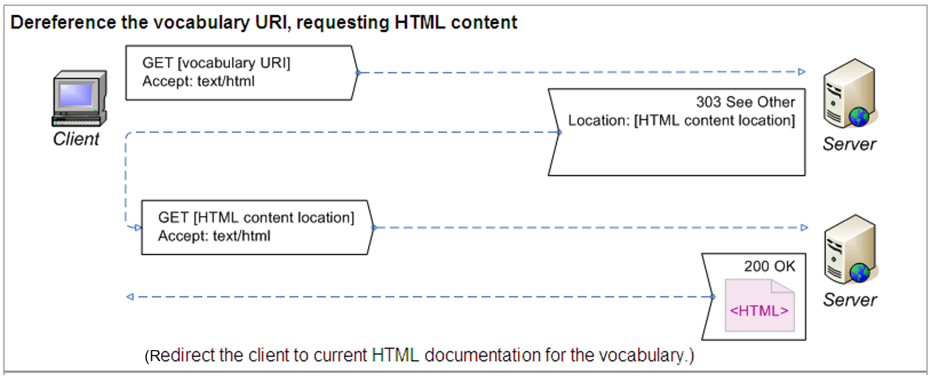

4

<http://www.cidoc-crm.org/cidoc-crm>

redirects (303 see other) to

<http://www.cidoc-crm.org/html/5.0.4/cidoc-crm.html>

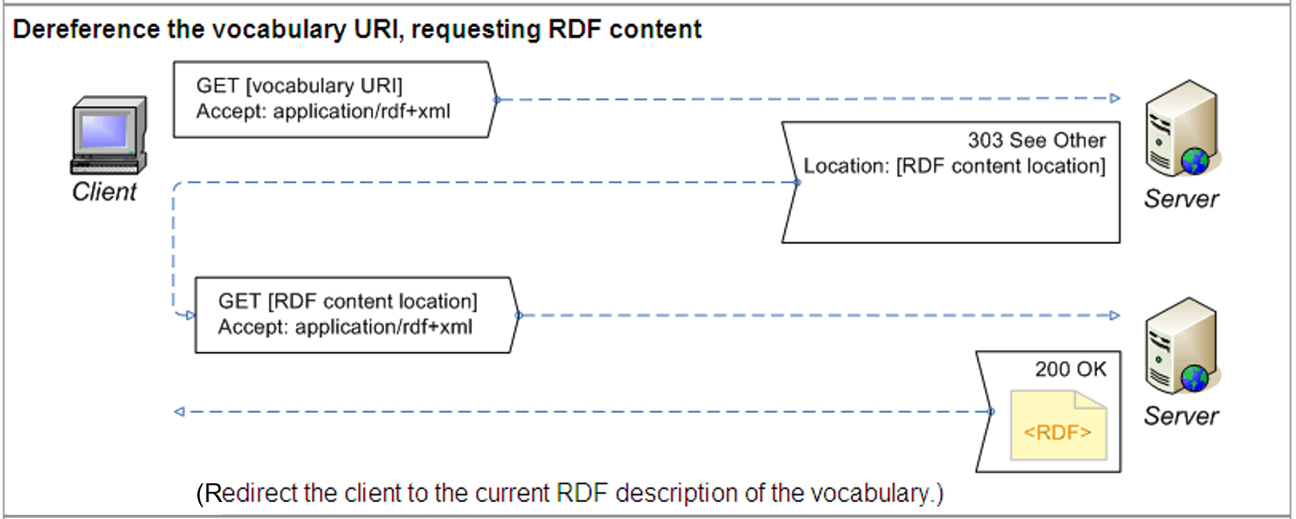

<http://www.cidoc-crm.org/cidoc-crm>

redirects (303 see other) to

<http://www.cidoc-crm.org/rdfs/5.0.4/cidoc-crm.rdf>

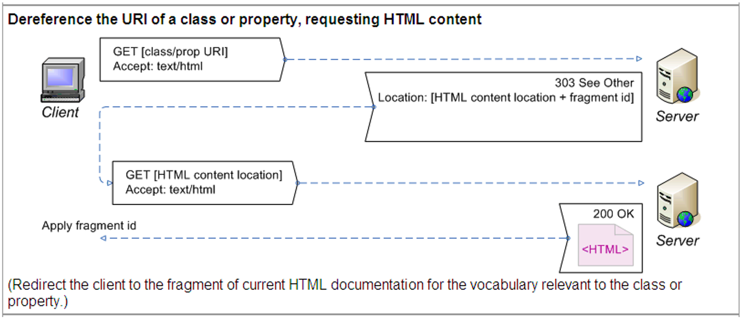

<http://www.cidoc-crm.org/cidoc-crm/E5_Event>

redirects (303 see other) to

<http://www.cidoc-crm.org/html/5.0.4/cidoc-crm.html#E5>

and

<http://www.cidoc-crm.org/cidoc-crm/P148_has_component>

redirects (303 see other) to

http://www.cidoc-crm.org/html/5.0.4/cidoc-crm.html#P148

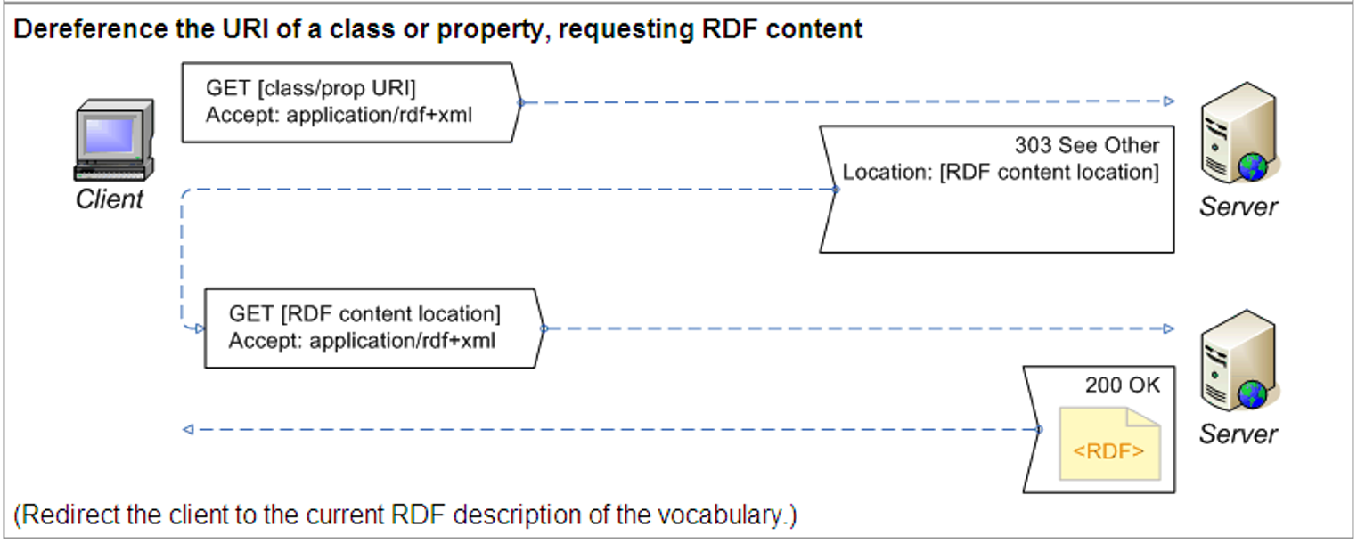

<http://www.cidoc-crm.org/cidoc-crm/E5_Event>

redirects (303 see other) to

<http://www.cidoc-crm.org/rdfs/5.0.4/cidoc-crm.rdf#E5>

and

<http://www.cidoc-crm.org/cidoc-crm/P148_has_component>

redirects (303 see other) to

http://www.cidoc-crm.org/html/5.0.4/cidoc-crm.rdf #P148

**Backwards compatibility**

For backwards compatibility we configured our server to resolve old-formatted URIs such as:

* <http://www.cidoc-crm.org/cidoc-crm/E5> to be valid and identical to URI <http://www.cidoc-crm.org/cidoc-crm/E5_Event>
* <http://www.cidoc-crm.org/cidoc-crm/P148>, <http://www.cidoc-crm.org/cidoc-crm/P148F> to be valid and identical to URI <http://www.cidoc-crm.org/cidoc-crm/P148_has_component>
* <http://www.cidoc-crm.org/cidoc-crm/P148i>, <http://www.cidoc-crm.org/cidoc-crm/P148B> to be valid and identical to URI <http://www.cidoc-crm.org/cidoc-crm/P148i_is_component_of>

1. Tom Heath and Christian Bizer (2011) Linked Data: Evolving the Web into a Global Data Space (1st edition). Synthesis Lectures on the Semantic Web: Theory and Technology, 1:1, 1-136. Morgan & Claypool. [*http://linkeddatabook.com/editions/1.0/*](http://linkeddatabook.com/editions/1.0/) *(see sections 2.3.1 and 4.1.3).*
2. [*http://www.w3.org/TR/swbp-vocab-pub/#recipe4*](http://www.w3.org/TR/swbp-vocab-pub/#recipe4)
3. In the following of this report, we consider v5.0.4 as the current CIDOC-CRM version.